Name : Priyav Mehta

UID : 2018130026

Batch : B Group Number : 3

**TASK – 1**

Screenshots :

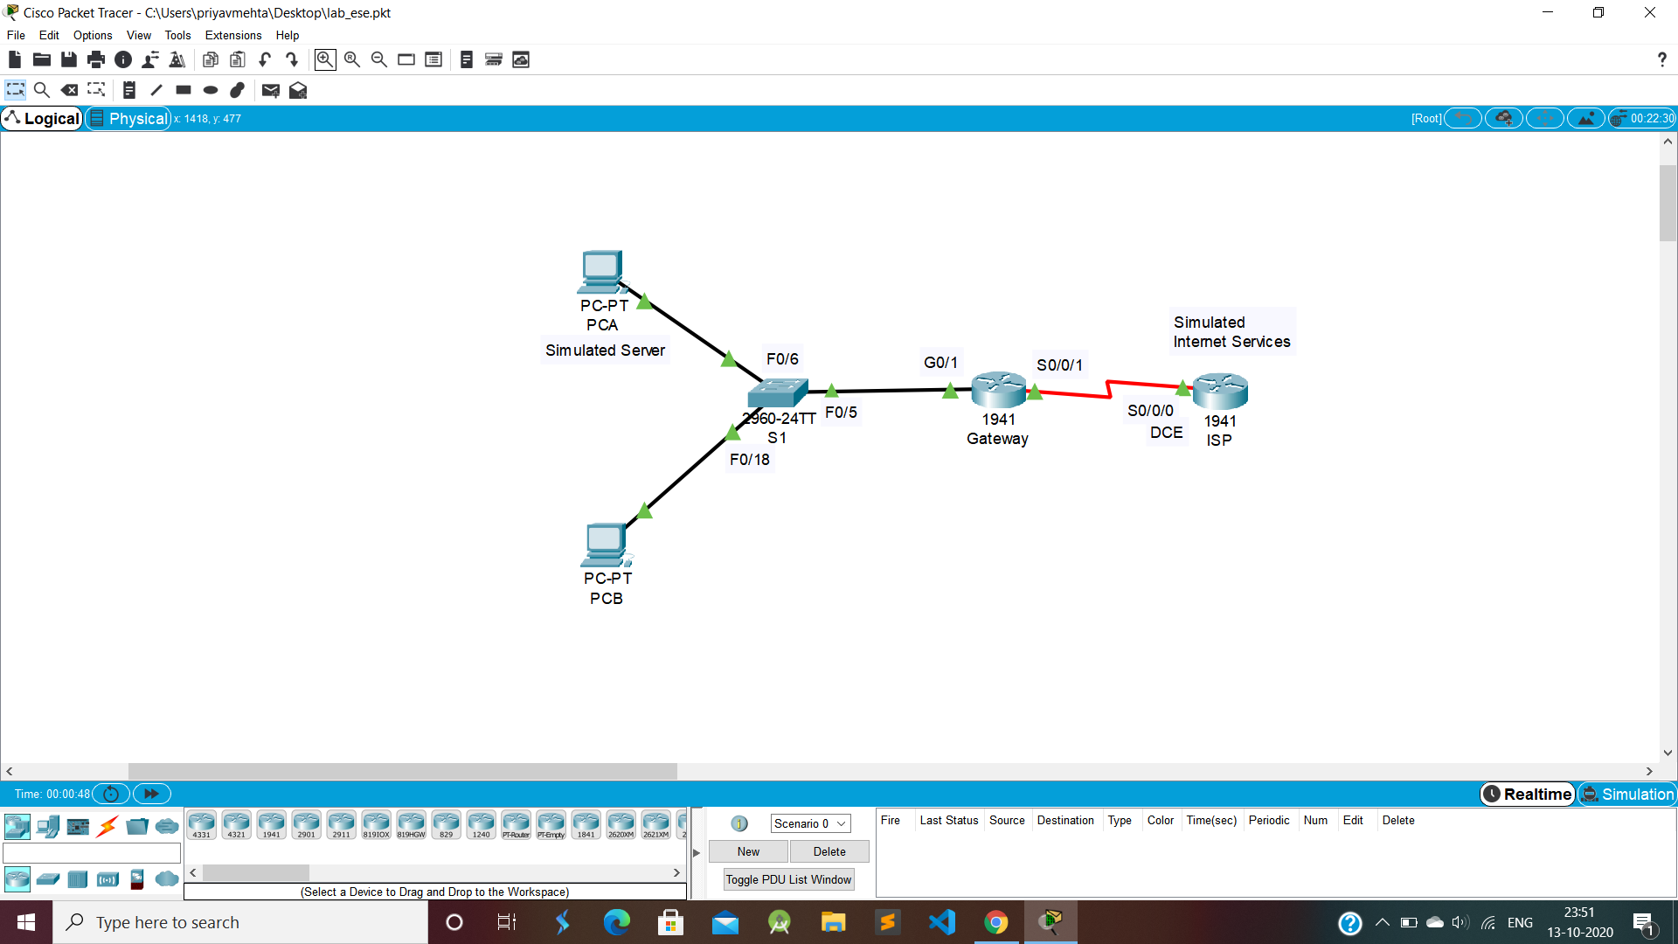

Above figure shows topology and configurations of the network

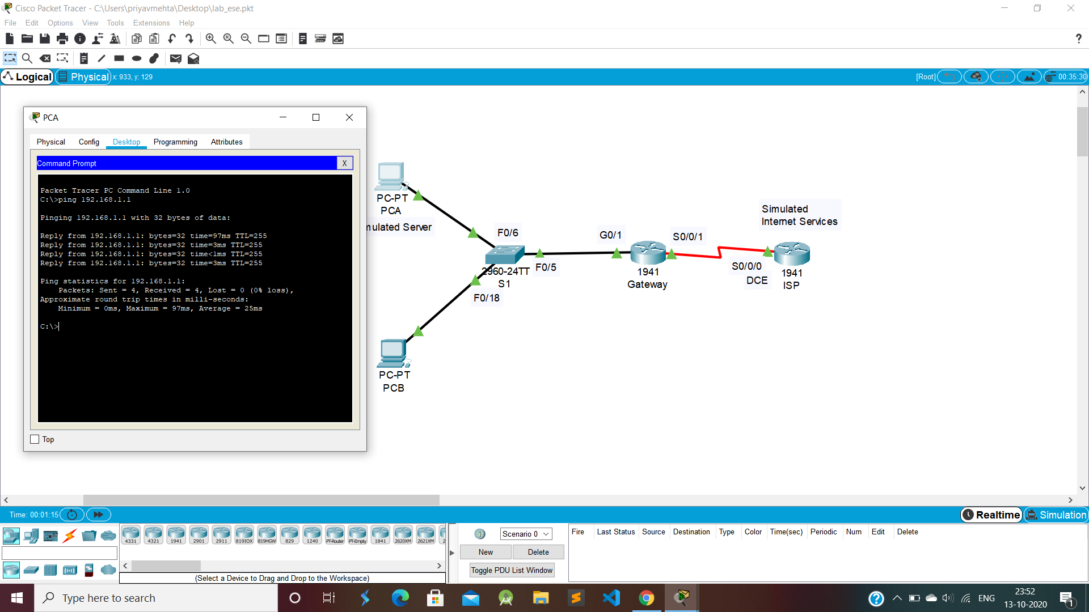

Above figure shows a successful ping command from PC-A to Gateway router

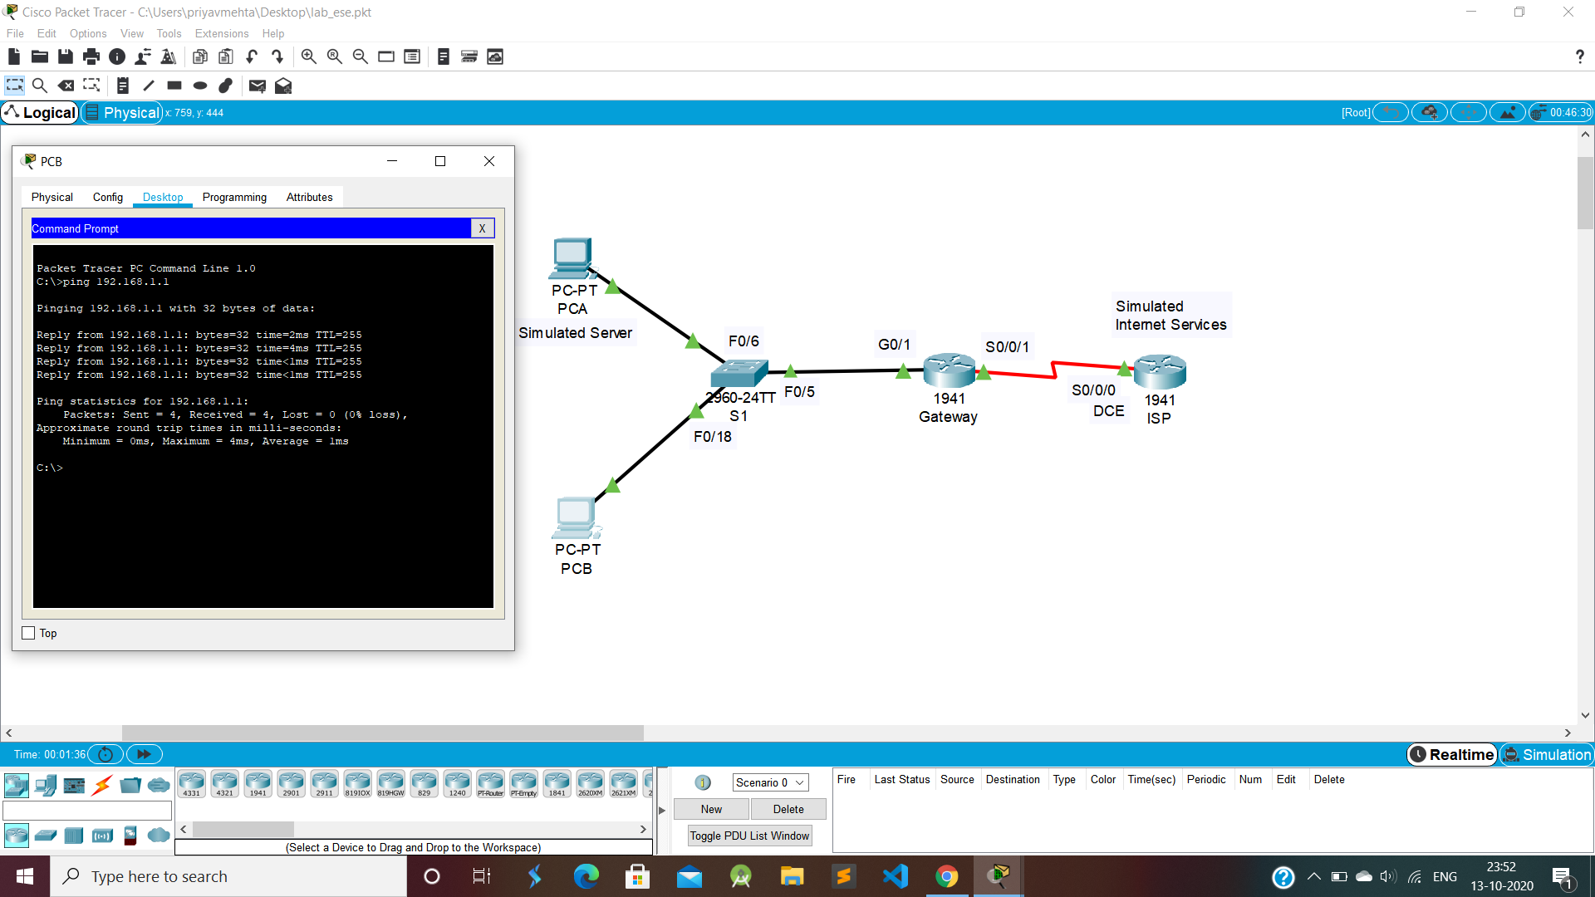

Above figure shows a successful ping command from PC-B to Gateway router

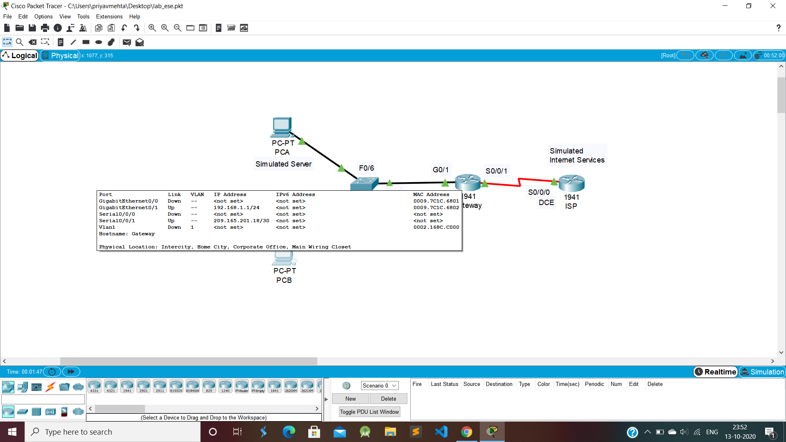

Above figure shows the configuration of the Gateway router

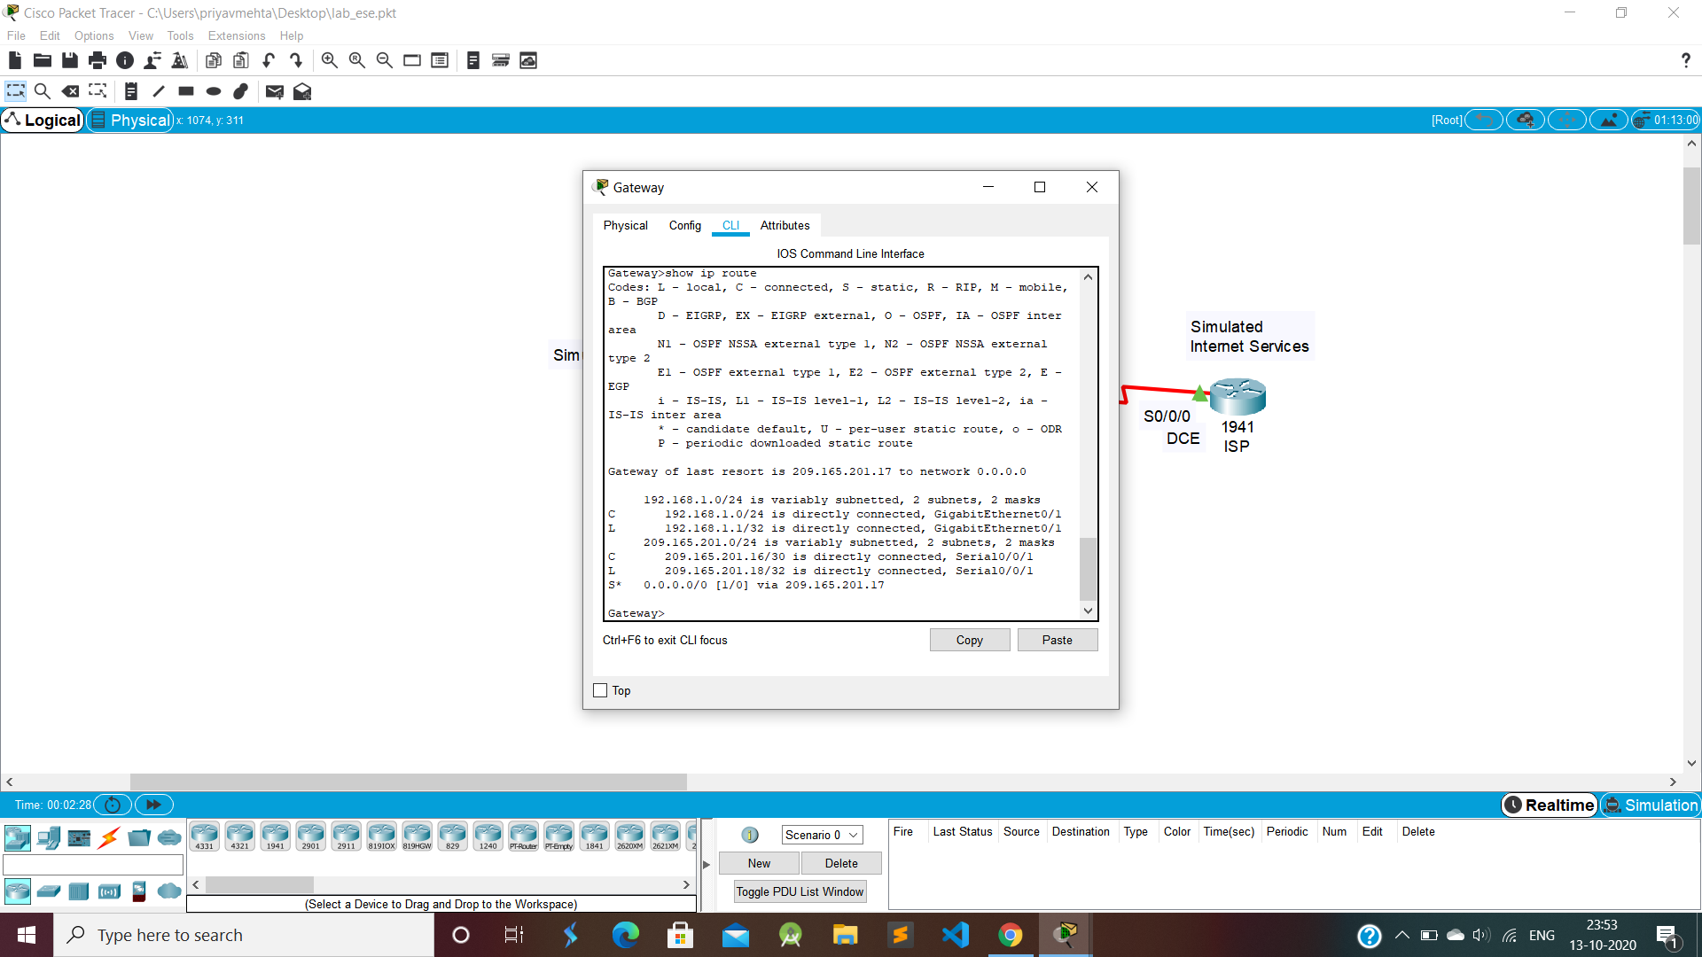

Above figure shows the result of the **show ip route** command in Gatway CLI

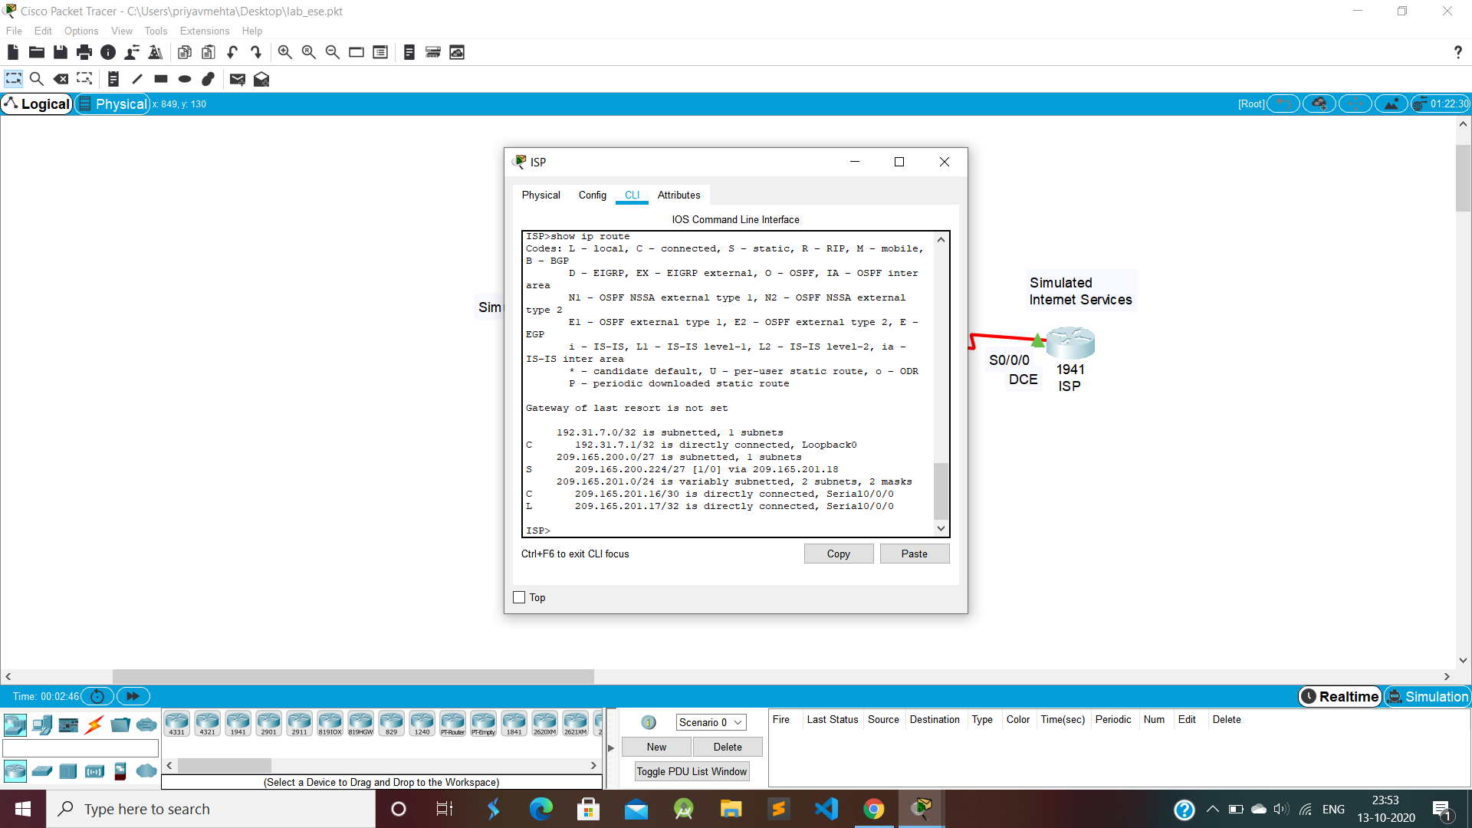

Above figure shows the result of the **show ip route** command in ISP CLI